ERMS Upcoming Bees

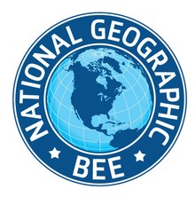
National Geography Bee
-January 22, 2019 @ 3 PM
-ERMS LGI Room
Parents are welcome
1st place qualifies for the state test and wins $75 gift card
2nd place wins a $25 gift card
See the main office or Social Studies teachers for more information
Open to all grades

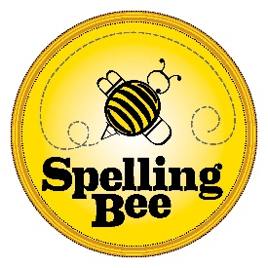
Spelling Bee
-January 23rd @ 3 PM
-ERMS LGI Room
Parents are welcome
1st place qualifies for the regional spelling bee and wins $75 gift card
2nd place qualifies for the regional spelling bee wins a $25 gift card
See the main office or English teachers for more information
Open to all grades

