[](https://www.bing.com/images/search?view=detailV2&ccid=7eh30IpG&id=5CF9B7F8A475ACD1D985CC9C552E8CF2E0528C97&thid=OIP.7eh30IpG83fsfbE_F8jLyQHaHa&mediaurl=http://www.designerclipart.com/image-files/SportsIlovesports.png&exph=1000&expw=1000&q=sports+clipart&simid=608005241243173970&selectedIndex=0)



Notes from Mr. Kessel and Mrs.

Cole in the Guidance Office

6th graders will be invited to the 2nd annual Elective Expo on January 24th during Connect.  This will be an opportunity for students to learn about what elective opportunities are available to them as 7th graders.  Counselors are heading into 6th and 7th grade classes in early February to talk with students about elective enrollments for next year.  Be on the look out for those forms.

01.21.2019



I want to thank both the staff and the students for what has been a great transition to East Rockford.  I do miss the students and staff at the 10-12 building, but East Rockford already feels like home.  It is the mid-point of the year and planning has begun for the 2019-2020 school year.  We are finalizing course descriptions for elective courses, hosting an elective expo for students, and will begin the enrollment process for next school year by the middle of February.  In the move to trimesters, conference dates were also adjusted, so please remember conferences will be next week Thursday (1/31), from 5:00 to 8:00.  We look forward to seeing you then.  Have a great week and stay warm!

~Mr. Burkholder



Mr. Avink

Student Activities Coordinator

**Future Home Dates:**

1/29- G. 8th grade Bball

1/31- G. 7th grade Bball

1/31- B. Swim/Dive @ RHS

2/4- G. 7th grade Bball

2/5- Wrestling @ ERMS

2/6- G. 7th grade Bball

2/7- B. Swim/Dive @ RHS

*\*All start times are 4:00 PM*

We are beginning our Winter II Athletics

-Girls Basketball

-Boys Swim/Dive

-Wrestling

**Upcoming Event**

1/31 – Parent/ Teacher Conferences (5:00-8:00 p.m.)

2/15 – Half day (10:55 dismissal)

2/18 – No School (mid-winter break)

3/1 – Last day of trimester

3/8 – Half day (10:55 dismissal)

3/12 – PAC meeting 9:00 a.m.

3/28 – Spring break starts

.



**After School Activities**

We are finalizing a list of after school activities; including boys volleyball, board games, creative writing, and even cooking. We will get information out to parents via family access in the coming week(s) and have sign ups at lunch!



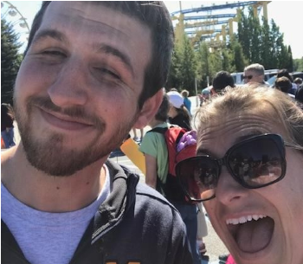

The 9 Mile Tribune

