



Notes from Mr. Kessel and Mrs.

Cole in the Guidance Office

Today, March 21, during Connect, 8th grade students will be filling working on a preadministration session of the PSAT 8/9, which will be taken on April 9, 2019.”

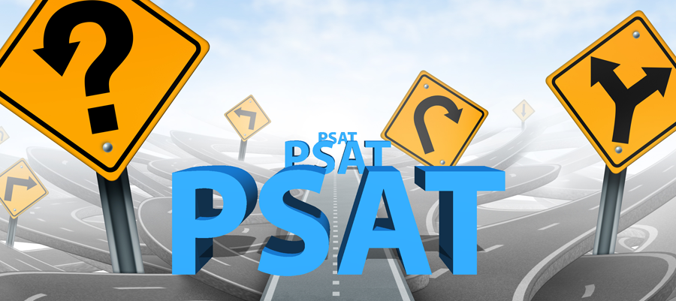

03.21.2019



As we approach spring break, ERMS students and staff are preparing for testing once we return.  Above and beyond testing we are also looking forward to two unique opportunities for our student and staff here at East.  In late April, Ginger Zee from Good Morning America will be spending time with our sixth graders.  Ginger is a Rockford graduate and looks to give back to our community whenever she can.  The visit was organized by Michelle Falk our librarian, and both middle schools will have a chance to meet Ginger and hear some pretty unique stories about weather, meteorology, and Gingers professional journey.  Secondly, for the first time our middle schools will be taking part in the “Grad Walk”.  This will be the fourth year of the event.  In late May, just prior to graduation, our senior class will enjoy lunch at the high school together, put on their caps and gowns, hop on school busses, and will then visit their elementary and middle schools.  If you know of a graduate who has participated in this event, you have probably heard about how neat it is. It is a great opportunity and experience for all of our students and staff.  For those of you who are traveling for spring break, safe travels! ~Mr. Burkholder



Mr. Avink

Student Activities Coordinator

Athletics

Spring is here! Here are some home dates

4/11- Boys Tennis

4/16- Track and Field

4/25- Track and Field and Boys Tennis

4/30- Boys Tennis

**Upcoming Events**

3/28 – Spring break starts

4/8 – School resumes

4/9 – PAC meeting 9:00 a.m.

4/9 – 8th Grade PSAT

4/24 – Parent/teacher conferences 3:30-6:30

4/26 – Mini Relay for Life

5/13-5/17 – 6th grade Camp

5/14 – PAC meeting 9:00 a.m.

5/17 – 8th Grade Dance

.



**After School Activities**

We are working on getting a list of new Spring activities to offer following spring break. Stay tuned for more information on that!

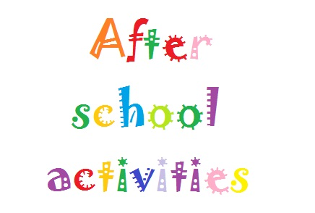

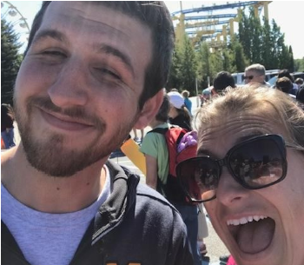

The 9 Mile Tribune

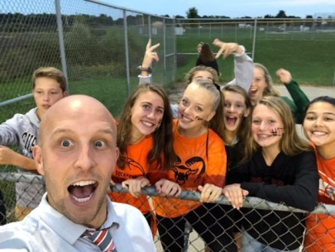

***Our spring sport offering includes girls/boys track and field and boys tennis.