



Notes from Mr. Kessel and Mrs.

Cole in the Guidance Office

- If your student has not turned in their elective enrollment forms for next year they should turn them in to the guidance office as soon as possible.

-Changes for electives for Tri3 must be made in writing to the guidance office by 3/8. These changes are not guaranteed, but we can look into them. Changes to core classes cannot be made.

03.05.2019



It is a time of transitions and testing at East Rockford!  This is the last week of second trimester and starting next week Monday, 7th and 8th grade students will begin their new elective classes.  Sixth graders recently had the opportunity to choose possible elective classes for next year and have that to look forward to!  Spring is an exciting time in the middle school.  Eight graders are ready to be freshman, seventh graders are looking forward to being leaders within the school, and sixth graders for the first time next year will experience six teaches in six different hours, while welcoming our incoming 5th graders.  As a building we just wrapped up winter MAP testing and your student should have brought these results home last week.  The week we come back from spring break, 8th graders will be taking the PSAT 8, which officially kicks off our state testing calendar, and will conclude in the last week of May.  It’s a busy and exciting time of year.  Have a great rest of the week and stay warm! ~Mr. Burkholder



Mr. Avink

Student Activities Coordinator

**Future Home Dates:**

3/4 – 7th grade girls basketball

3/5 – Wrestling quad

3/6 – 8th grade girls basketball

3/7 – 7th & 8th grade girls basketball

3/11 – 7th grade girls basketball

3/12 – 8th grade girls basketball

*\*All start times are 4:00 PM\**

Wow! What a crazy couple of weeks! Thank you to all parents, students and staff for your flexibility as we rescheduled games.

**Upcoming Events**

3/8 – Half day (10:55 dismissal)

3/8 – Last day of 2nd trimester

3/14 – 5th grade parent/student orientation – 6:00 p.m.

3/28 – Spring break starts

4/8 – School resumes

4/9 – PAC meeting 9:00 a.m.

4/24 – Parent/teacher conferences 3:30-6:30

.



**After School Activities**

We are working on rescheduling some after school opportunities as we canceled many with the snow days that occurred. Please stay tuned as we work through these offerings.





The 9 Mile Tribune

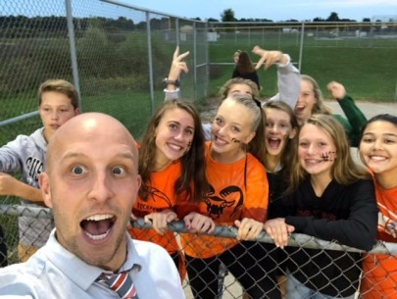

***Our spring sport offering includes girls/boys track and field and boys tennis. The start date for these sports is 3/18. Sign ups are held at lunch.***